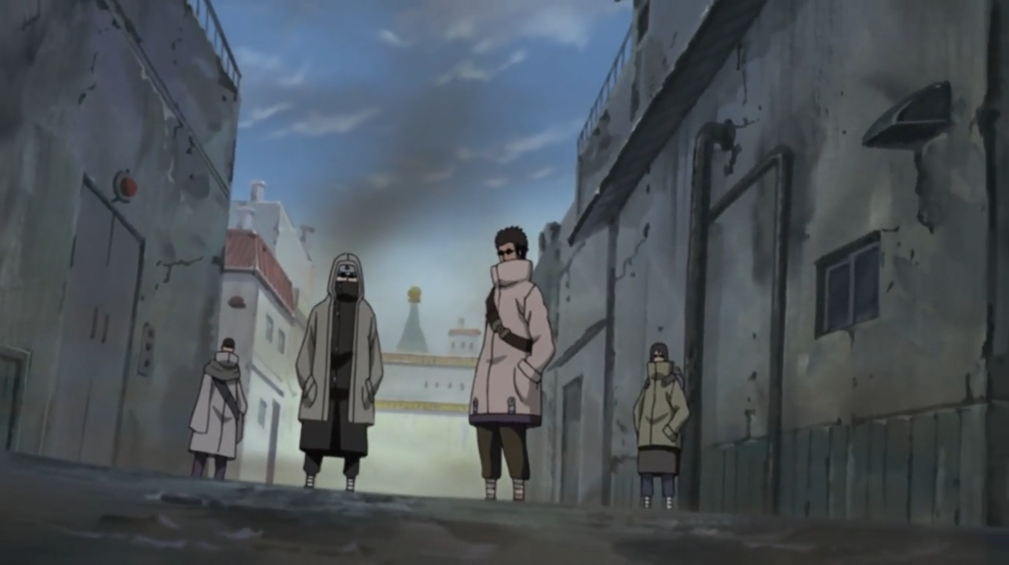

**Aburame Clan**

The Aburame Clan (あぶらめ一族, Aburame Ichizoku) is one of the three clans that reside in Watashitachi, wa Keikensho. Their strength is directly derived from the insects they’ve gained a symbiotic relationship with. Aburame at birth are introduced to Kikaichu allowing each of them to use these bugs, but some members have been known to use special species of insects.

History

**Preface**

The Aburame started as a small congregation of clanless who searched god, hypothesizing that due to the beast’s immense power one of the many had to be some form of deity. As the Age of Beast came to an end their numbers began to dwindle severely and even the most devote members began to lose faith. In miraculous fashion, as the Age of Beast had fully come to a close, they discovered a badly injured beast, it had wounds that seemed impossible and various insects skittering in and out of its form. They quickly realized that the beast was dead and being controlled by something otherworldly, their efforts to commune with the now reanimated beast proved fruitless. One of the more devote members figured that the only way to understand the beast was through the many insects upon its form. He allowed the skitters insects to crawl upon him, and through ever orifice on his body. He felt them crawling through his body and soon began to hear small whispers as they conjoined themselves with his very being. He was awakened instantly to knowledge of the insect controlling the beast, knowing it was called the Tenraikouchuu and it’s only goal was to unite all under something it called the One-Mind. Many members began to offer themselves to the Tenraikouchuu, and some would gain the same abilities as the first man to do so, others would be consumed violently by the bug- being deduced as “Not having enough faith” by onlookers. The Tenraikouchuu through time moved from body to body to survive but as time passed and the presence of beast began to fade, it began to lose hosts. If the body was too weak it would simply rot away from the very presence of the being.

**Current**

The Aburame are a religious clan, praying that the One-Mind in hopes that it will come and make the world “Whole” as the refer to it. They believe if they find the Tenraikouchuu a fitting host that it could have the power to somehow summon the One-Mind into their plane of existence. They still search for an ancient beast of great power, or a person with extraordinary resolve for which the Tenraikouchuu, who is currently without a body and slowly dying, to take over. The clan, because of this, is dying out as the ability to turn others into Aburame can only be restored by revitalizing the Tenraikouchuu. Most of their efforts of shinobi warfare go towards gaining power and a means by which to find the body while supporting their own house.

Description

Aburame a known to wear very heavy clothing to hide the manner bugs that skitter and crawl onto, inside, and from their flesh. They often wear protective shades due to having crepuscular vision, one of the side effects of hosting the insects. Their eyes are very light sensitive.

Aburame are very religious, but sometimes come off as being blighted with madness due to their constant muttering from speaking with their insects. They often refer to *The One-Mind* in a godly sense.

Player Guide

*Aburame are low spoken and naturally calm people, they often speak in very low tones. They are not outrightly religious as to cast their religion on anyone, or even when asked about it, but they are very devoted to the idea of the One-Mind. Though “Spreading the Word” will not aid in their attempts to bring it upon the world. They are known to be indifferent to most things but show excitement in insects.*

-Aburame are often speaking with their own insects in a hushed manner, almost seeming like their talking to themselves to others but this is perfectly normal to other Aburame.

- Aburame, rather than killing, often capture subjects for experimentation with the effects certain bugs have people. It is more likely they will capture someone has a test subject then killing them.

- They often wear long coats, baggy pants, and clothes that don’t reveal much of their body. This is to keep their body at a proper temperature due to the Insects inside being very susceptible to minuet temperature changes.

-Aburame are known to remove their shades at night time or inside of dark buildings as not much light is able to bother their sensitive eyes.

-Aburame often use vocabulary that refers to insects when speaking of humans, calling their homes “Nests” and the House Keikensho as “The Hive”. They refer to people who the deem weak or worthless as “Simple workers” and high-ranking people as “Kings” or “Queens”.

-Aburame have a more advanced education, they are deep understanding of both Science and Math, even enough to perform experiments on subjects with no formal training. Their skills in other subjects a slightly more advanced than most other highly educated clans.

-Aburame have the ability to digest much of an insect’s pallet, such a greenery and even other bugs. They seem to mostly enjoy warm drinks such a tea and coffee. Aburame have an extreme love for chocolate, although it is a rare and expensive candy.